**Webinar by Connected Investor**

September 22, 2020

Connectedinvestors.com Ross Hamilton, CEO

910-778-76000

“*There are no bad markets. Just bad strategies for the market you are in*”

Agenda:

* Introduction
* State of the union
* Strategy Session
* The PiN Method
* Search your market
* What to do in this market and why
* How to make money quickly in RE
* How to find properties at steep discount
* How to save $1000s of dollars a month
* How to automate the ‘hardest’ aspects
* How to predictability during uncertainity
* How to save 1000s of hours of work

*Self-made does not mean self-financed*

*Everyone is self-made, only the millionaires admit it*

People profit from real-estate inefficiencies

Experienced Investors

* Lead flow Pre-REO
* New Data Layering
* Direct deal flow



Insider Secrets

* Look for data, not deals
  + In RE using data (insider information) to profit makes you smart and rich and is legal

Dave Stech - State of the Union for RE Investors

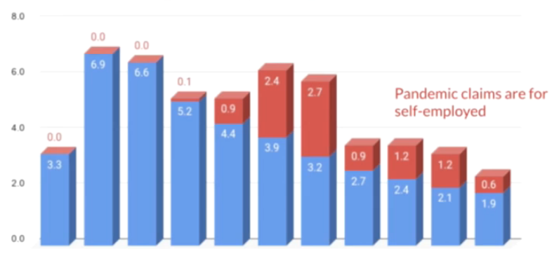

Employment will bounce back next year, but after disastrous this year

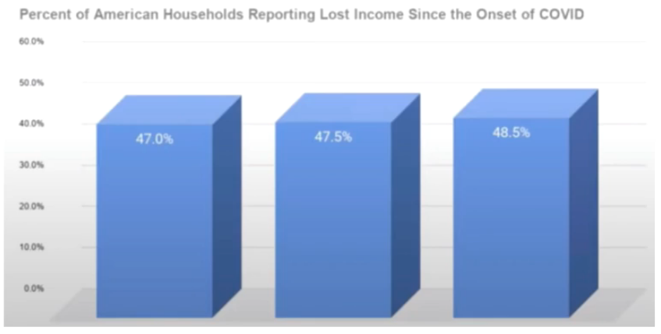

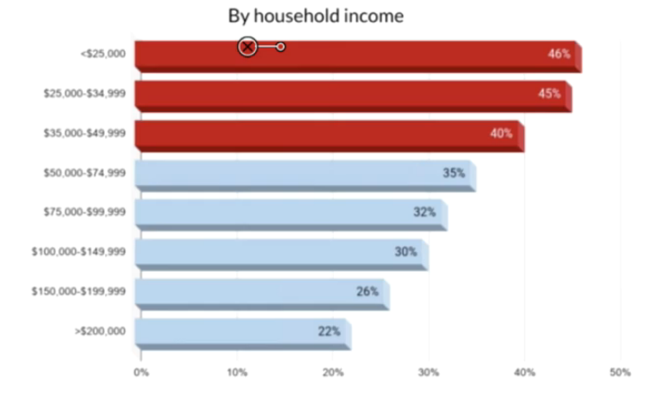

Higher your income, less likely to lose income

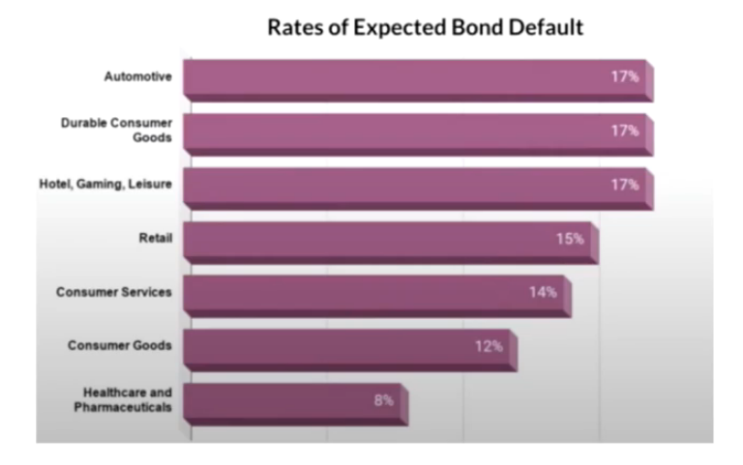

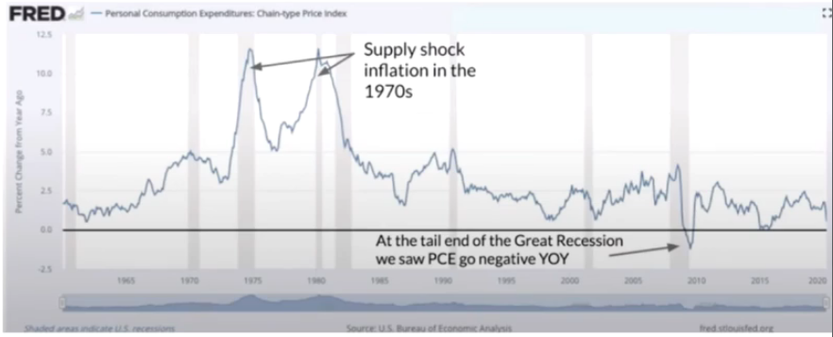

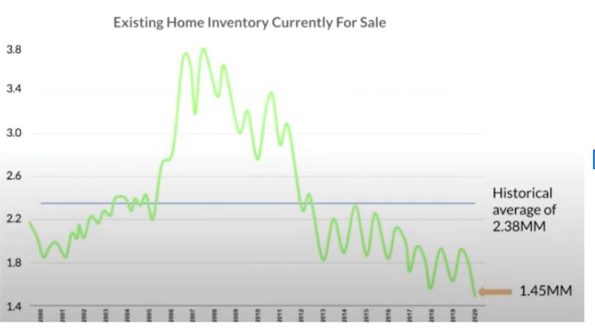

* Listing price up 10%
* sales price goes up 3%
* Reason low supply
* Mortgages up 18%
* Affordability up
  + Sales price (slightly up)
  + Interest rates (down)
  + Income (uncertain)
* Focus on short-term residential real-estate
  + Do “easy” flips
  + Wholesale
  + Focus on Pre-foreclosures
  + Find vacant houses
  + Buy from tired landlords
* Stay away from
  + Factories, warehouses, shopping malls, retails, office, hotels, self-storage, multifamily (overbuilt), AirBnB

*“Never let a good crisis go to waste”* - Winston Churchill

2020 – 21 – will probably get back in about 2022-23

Best Strategy Now (Microflipping)

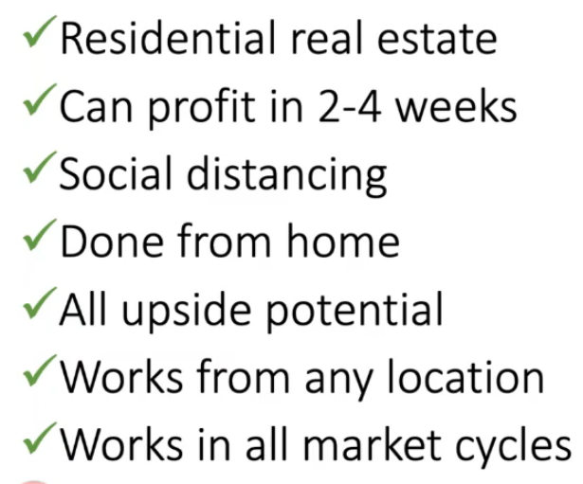

Micro-Flipping

* Does not mean low dollar deals
* Does not mean small profits
* it refers to the time – fast
* No cash or credit
* 100% virtual?
* Easy

Wholesaling using and e-e data platform that allows you to charge an assignment fee by connecting buyers and sellers of investment real estate real

Steps

* Select the property
* Control property
* Fill the order
* Cash the check
* Flipping properties that are not in need of major repair to retail buyers
  + Cleaning up
  + Paints

PiN Method

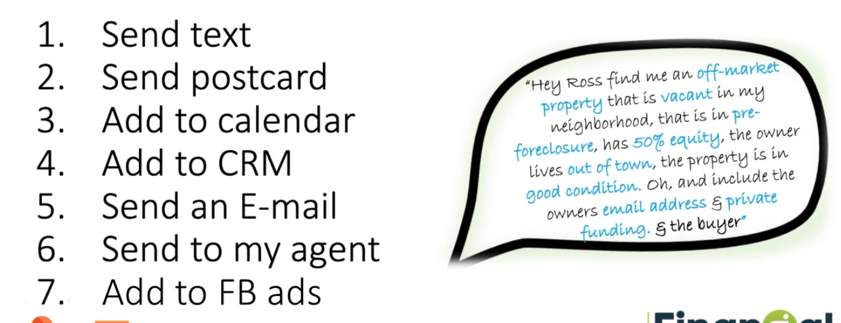

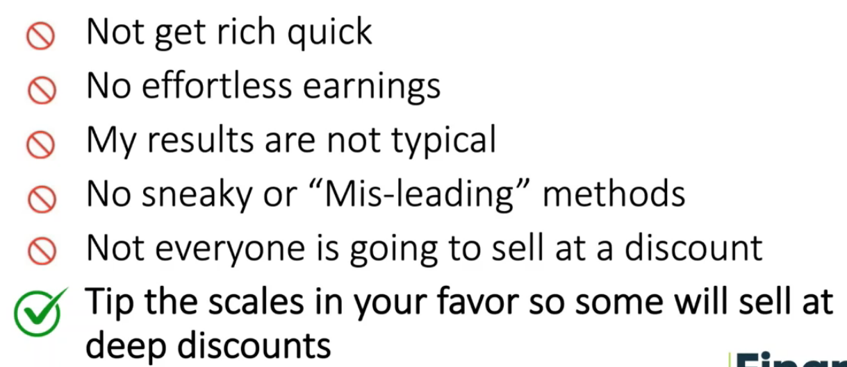



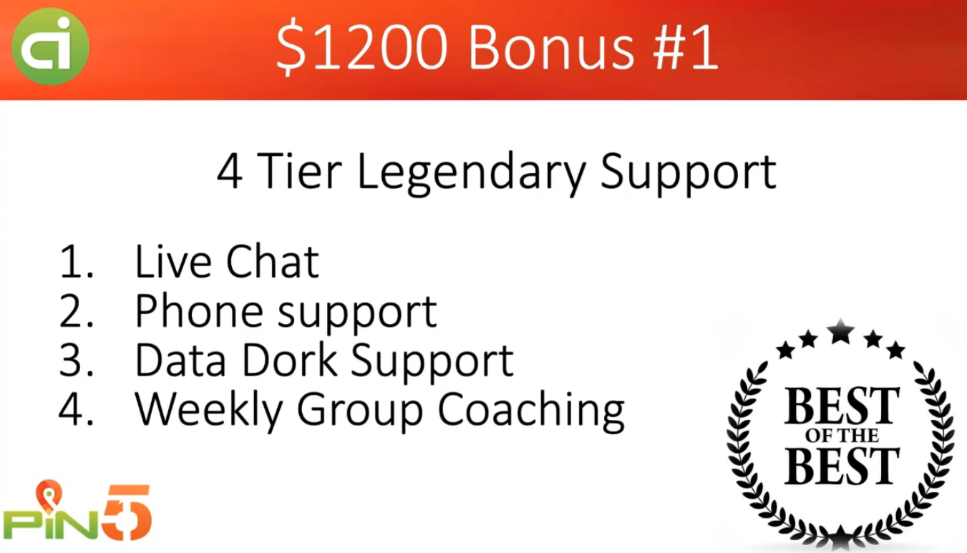





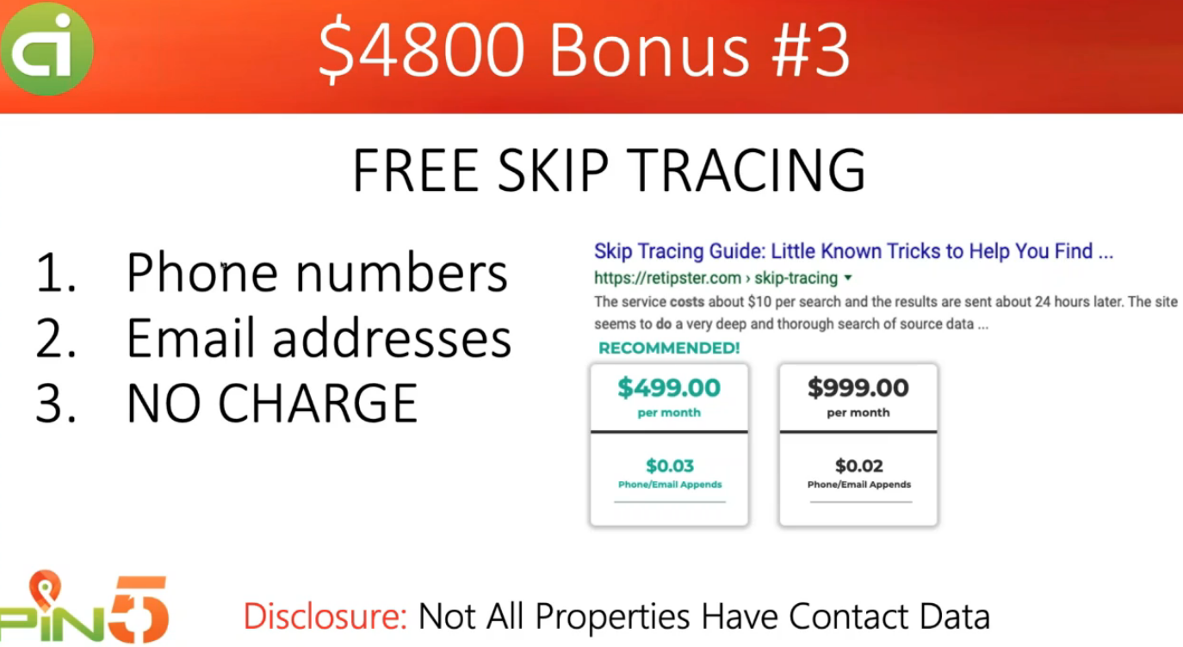

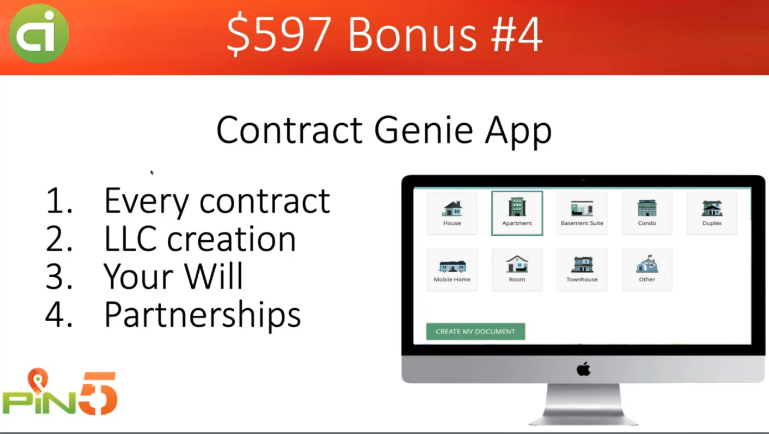

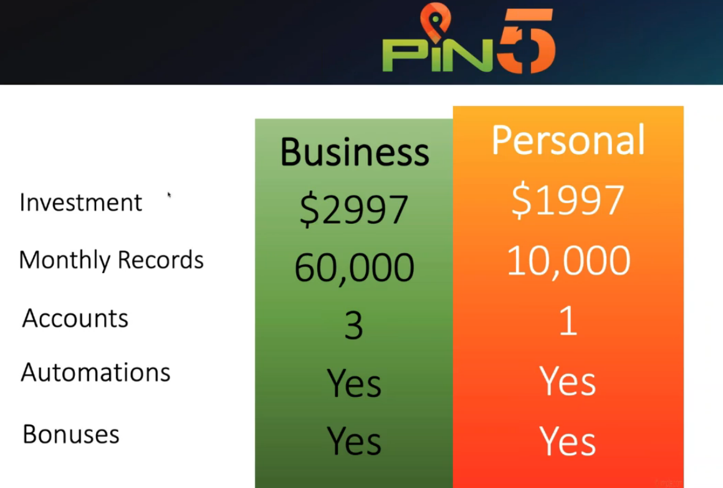

For now, $1497

40K records

2 accounts

